2024 Stream Flow and Temperature Monitoring Report
Tumalo Creek: Stations 14070920 and 14070980
Kyle Wright, Hydrologist, Deschutes National Forest

This report is produced in accordance with Special Use Permit BEN1158, and conditions set forth for monitoring the effects of the diversion of municipal water from the Bend Municipal Watershed over the duration of the City of Bend’s Special Use Permit (SUP). The Bend Municipal Watershed is situated on a portion of the Deschutes National Forest that was designated in 1926 for the protection and production of high-quality drinking water for the City of Bend. Stream flow and temperature monitoring was carried out on upper Tumalo Creek for the 2024 calendar year below the confluence of Bridge Creek and Tumalo Creek known as Location A (Station ID 14070920) at river-mile ~15.8, and further downstream at Location B, upstream of the Skyliners Bridge, (Station ID 14070980). Temperature monitoring was also carried out at Location C near river mile ~3.2, by the City of Bend (Figure 1). Figure 2 shows the various administrative boundaries as they relate to the monitoring locations.

Figure 1. Monitoring station map.

The City of Bend contracted with the Oregon Water Resources Department (OWRD) to install the two temperature and flow gaging stations mentioned above to aid the US Forest Service and the City of Bend in monitoring the effects of municipal water diversions by the City of Bend and to help guide adaptive management as called for in the Special Use Permit. Station 14073520 located at RM 2.8 also provides flow and temperature data for Tumalo Creek, however it is located below Tumalo Irrigation District’s (TID) surface water diversion. Flow characteristics of the stream affected by water management at this location are driven by TID’s operations, and not the operations of the City of Bend’s municipal water system.
Flow monitoring data from the two OWRD gauges presented in this report were obtained and processed following procedures established by the U.S. Geological Survey’s Measurement and Computation of Streamflow: Volumes 1 & 2 Measurement of Stage and Discharge (USGS, 1982). Temperature data was obtained and processed by OWRD following USGS guidance and protocols outlined in the National Field Manual for the Collection of Water-Quality Data (USGS, 2006), and Guidelines and Standard Procedures for Continuous Water-Quality Monitors: Station Operation, Record Computation, and Data Reporting (Wagner et al., 2006). The City of Bend follows similar procedures outlined in their Standard Operating Procedures (2014), and the Environmental Protection Agency’s manual for Best Practices for Continuous Monitoring of Temperature and Flow in Wadeable Streams (EPA, 2014). Past monitoring reports and related information about the Bend Municipal Watershed can be found on the City of Bend Utility Department Web page (https://www.bendoregon.gov/government/departments/utilities/stormwater/watershed).

Figure 2. City of Bend’s municipal watershed, Tumalo Creek gauging stations, and land ownership/management designations.

Streamflow Monitoring
Location A: Tumalo Creek Data at Station 14070920 below Bridge Creek Confluence:
Streamflow data collected at Station 14070920 (Figure 3) includes the cumulative surface runoff in Tumalo Creek and all of its upstream tributaries, minus the City of Bend’s municipal surface water diversion. Tributaries include Middle Fork Tumalo Creek, Bottle Creek, North Fork Tumalo Creek, Rock Creek, Spring Creek, Crater Creek Ditch (Tumalo Irrigation District diversion from Soda Creek subwatershed to Upper Tumalo Creek subwatershed), Bridge Creek (including partial flow diverted from Prowell Springs on the Middle Fork of Tumalo Creek), and several unnamed tributaries and spring sources. The City of Bend diverts water from Bridge Creek 0.2 miles upstream from its confluence with Tumalo Creek. Data from this gauge location illustrates the greatest direct effect the City’s diversion has on Tumalo Creek.

Figure 3. Location A - Station 14700920 flow data from 1/1/24 to 12/31/24.
With the operation of the City of Bend’s new water system, the City has the ability to respond to demand by diverting only the amount of water needed at the system’s intake, rather than a constant diversion of 18.2 cfs and managing demand by returning unneeded water from its distribution center at the Outback Station as was done with the previous system. With this change in operation, any unused water less than the 18.2 cfs permitted diversion potential is bypassed and remains in-stream through the length of Reach A (13.2 miles). This results in increased flow in Tumalo Creek (Figure 4).

Figure 4. Actual flow rates at Location A - Station 14700920 compared to instream flow rates that would have been seen in that location under a constant 18.2 cfs diversion rate of the previous system from 1/1/2024 to 12/31/2024. Current daily City diversion rates were converted to cubic feet per second (cfs) from millions of gallons per day.

During the calendar year 2024 monitoring period, the greatest seasonal flow improvements under normal operations were seen through the winter months (January – March, and October - December) with average flow increases of approximately 9.3 cfs. Maximum daily flow increase during normal operations was 11.6 cfs. (Figure 4).

Average daily flow increase between April 1 and September 30, 2024 was approximately 2.9 cfs. The minimum daily flow improvement during this time was 0.6 cfs. Average daily flow increases seen in Tumalo Creek for 2023 were approximately 6.3 cfs higher than what would have been recorded with the operation of the old system. (Figure 4).

Mean Daily Diversion

Figure 5. Diversion intake at Bridge Creek

During the 2024 calendar year there were two periods where no surface water was diverted from Bridge Creek for municipal purposes. The dates for the three period of no use were January 24th-January 29th, and June 17th-19th. The January shutdown was due to a computer issue and in June for maintenance.

Location B: Tumalo Creek Data at Station 14070980 at Skyliners Bridge:
Flow data at Station 14070980 includes the cumulative surface runoff in Tumalo Creek and all of its upstream tributaries, minus the City of Bend’s municipal surface water diversion (Figure 5). Surface water contributions include all of those named for the upstream gauge, as well as South Fork Tumalo Creek, Tumalo Lake Creek, and several groundwater sources along the approximately three miles between the two gauges below Bridge Creek, referred to as the accretion zone (Figure 6). This gauge captures all tributary inputs for Tumalo Creek below the City’s point of diversion and provides an assessment of net flow conditions for approximately 10 miles of stream prior to TID’s diversion at RM 2.8. The same flow increases under the operation of the new City of Bend water system discussed above applies through this gauge, and all downstream reaches to TID’s point of diversion. Minor instances where flow below Bridge Creek exceeds flow at Skyliners Bridge are a result of changed stream conditions during high flow events that alter the calibrated stage-discharge relationship, causing a minor error in discharge estimates.

Figure 5. Location B - Station 14700980 flow data from 1/1/2024 to 12/31/24.

Figure 6 Composite hydrograph shows flow accretion from tributaries and groundwater between gauges at Locations A and B.

Stream Temperature Monitoring

Within the Tumalo Creek watershed, Oregon State water quality standards for temperature vary. Above the confluence with Tumalo Lake Creek, the temperature standard is 12º C for bull trout spawning and juvenile rearing. This temperature standard was put in place during the period of time when Tumalo Creek was being considered for inclusion as designated critical habitat for bull trout. Following rigorous survey work that failed to find bull trout in this system, Tumalo Creek ultimately was not included as critical habitat for bull trout, but temperature standards have not yet been adjusted accordingly by the Oregon Department of Environmental Quality (DEQ). Below the confluence, the temperature standard is 18º C for salmon and trout rearing and migration.

Within the Tumalo Creek watershed where Tumalo Creek and its tributaries flow through National Forest System lands, riparian management objectives are described by both the Northwest Forest Plan (USDA, 1994) in the upper reaches of the watershed, and the Inland Native Fish Strategy (INFISH) (USDA, 1995) in lower reaches (Figure 2). While these management areas do describe general management objectives associated with stream temperature throughout the range of those management areas, they do not constitute or supersede water quality standards determining attainment or impairment of water quality standards established by the State on a reach-by-reach basis.

Location A: Tumalo Creek Data at Station 14070920 below Bridge Creek Confluence:
Instantaneous temperatures data were recorded at 15 minutes intervals at Station 14070920, providing an ongoing record over the life of the gauge. These data can be obtained at the OWRD’s Near Real Time Hydrographics Data website (https://apps.wrd.state.or.us/apps/sw/hydro_near_real_time/). For the purpose of analyzing and assessing stream temperature in the State of Oregon, the 7-day average maximum is used to assess water quality and determine if standards are being met (Figure 7).

At this location on Tumalo Creek, Oregon State water quality standard for temperature is currently set at 12º C. The highest 7-day average maximum temperature was 12.6 º C, exceeding the water quality standard for Tumalo Creek in the 2024 calendar year. The water quality standard of 12º C was exceeded for 11 days.

Figure 7. Tumalo Creek instantaneous temperature data at Station 14700920 from 1/1/2024 to 12/31/2024. The orange line indicates the Oregon State temperature standard of 12º C. The dashed orange line indicated the Oregon State standard of 18 º C for the downstream locations on Tumalo Creek.

Location B: Tumalo Creek Data at Station 14070980 at Skyliners Bridge:
Instantaneous temperature data are also recorded every 15 minutes at Station 14070920, with data provided at the same link provided above. At this location on Tumalo Creek, the Oregon State water quality standard for temperature is set at 18º C.

Figure 8 provides an analysis of the 7-day average maximum temperature in Tumalo Creek at Skyliners Bridge. Through the period of record, the highest 7-day average maximum temperature was recorded at 13.8 º C, below the State water quality standard.

Figure 8. 7-day average maximum temperature data for Tumalo Creek at Station 14700980 from 1/1/2024 to 12/31/2024. The orange indicates the Oregon State temperature standard of 18º C.

Tumalo Creek Data at Location C and Tumalo Irrigation District diversion temperature (OWRD #14073520):

The furthest downstream location for water temperature monitoring on Tumalo Creek that is not affected by the management of water by TID is at Location C (Figure 1). At this location on Tumalo Creek, the Oregon State temperature standard is also set at 18º C.
Figure 9 provides an analysis of the 7-day average maximum temperature in Tumalo Creek at Location C. Here too, the seven-day average maximum temperatures remained below the State water quality standard through the period of analysis. The highest 7-day average maximum temperature was recorded at 17.7 º C late July- early August.

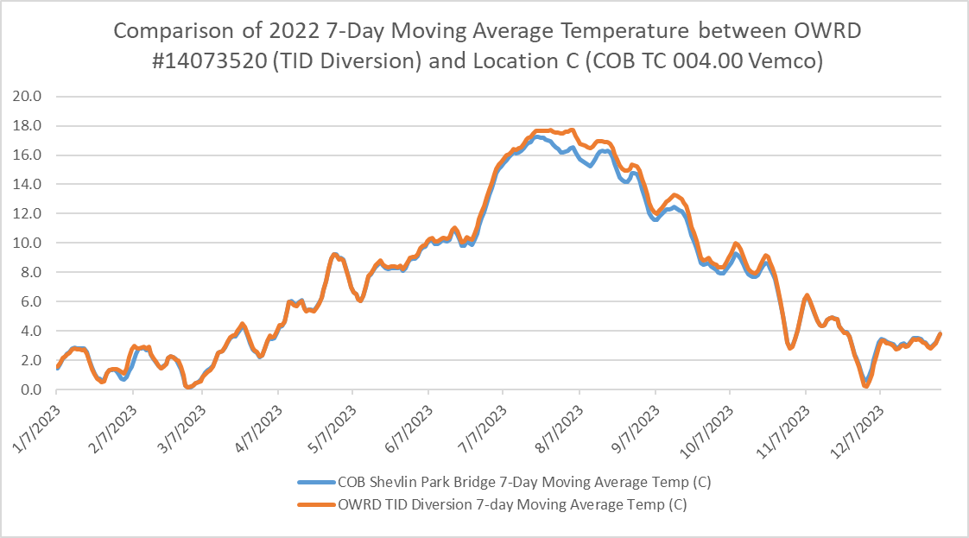
Figure 9. Comparison of 7-day average maximum temperature data for Tumalo Creek at Station 14073520 and Location C (COB TC) from 1/1/2024 to 12/31/2024. The orange indicates the Oregon State temperature standard of 18º C. COB TC 0004.00 was lost so no data was collected after August 19th, 2025.

Conclusion:
For the 2024 monitoring period, stream flow and temperature data collected below the City of Bend’s surface water diversion in Reach A did not indicate any adverse effects to the aquatic environment in Tumalo Creek because of operations. This year’s stream flows were on average 6.3 cfs higher in Reach A during normal operations than what would have been seen under the operation of the previous system when surface water diversions from Bridge Creek were a constant 18.2 cfs.
For Reach A, the 7-day average maximum stream temperatures of Tumalo Creek did exceed the 12ºC State water quality standard at Location A, but didn’t exceed the 18ºC at any of the locations.
Tumalo Creek naturally buffers stream temperatures at low flows as a relatively large proportion of runoff during periods of base flow is supported by springs and deeper groundwater. With the operation of the 2016 Updates to the City of Bend water system, when demand for surface water is less than 18.2 CFS, the un-diverted water, remains instream for the entire reach and helps to moderate stream temperatures throughout Reach A.

References:

U.S. Environmental Protection Agency (EPA), 2014. Best Practices for Continuous
Monitoring of Temperature and Flow in Wadeable Streams. Global Change Research Program, National Center for Environmental Assessment, Washington, DC; EPA/600/R-13/170F. Available from the National Technical Information Service, Springfield, VA, and online at http://www.epa.gov/ncea.

U.S. Geological Survey (USGS), 1982. Measurement and Computation of Streamflow: Volume 1.
Measurement of Stage and Discharge. Geological Survey Water-Supply Paper 2175. United States Government Printing Office, Washington D.C.

U.S. Geological Survey (USGS), 1982. Measurement and Computation of Streamflow: Volume 2.
Computation of Discharge. Geological Survey Water-Supply Paper 2175. United States Government Printing Office, Washington D.C.

U.S. Geological Survey (USGS), 2006. National Field Manual for the Collection of Water-Quality Data.
U.S. Geological Survey (USGS), 1882. U.S. Geological Survey TWRI Book 9. http://pubs.water.usgs.gov/twri9A/.

Wagner, R.J., Boulger, R.W., Jr., Oblinger, C.J., and Smith, B.A., 2006, Guidelines and standard
procedures for continuous water-quality monitors—Station operation, record computation, and data reporting: U.S. Geological Survey Techniques and Methods 1–D3, 51 p. + 8 attachments; accessed April 10, 2006, at http://pubs.water.usgs.gov/tm1d3.

