Tree Regulation Update Advisory Committee Meeting Recap

Oct. 18, 2023
Want to stay in the loop about tree regulation? Here’s what you need to know.
The context:
Earlier this year, the Bend City Council created a temporary committee – The Tree Regulation Update Advisory Committee (TRUAC) – to explore preserving trees during new development while producing needed housing in the community.
The Council has explicitly directed this committee to focus on rules related to new, large-scale developments – like large subdivisions or commercial projects – rather than regulating what an individual homeowner, for example, chooses to do with a tree on their property.
Not finalized Re commendations to Date:
- Inventoried and Mapped Trees (Regulated Trees): 6” or larger (Deciduous and Coniferous)
- Priority Trees for Preservation: 20” or larger (Deciduous and Coniferous)
- Preservation percentages: 20% of priority trees would need to be preserved, or 25% of the total diameter at breast height (DBH) on a site would need to be preserved
- Mitigation ratios: For every tree of a certain size taken down, the number of trees that would have to be planted. The proposal currently: 6” to 9.9” – One tree; 10” to 19.9” - Two trees; 20” or larger - Four trees
The discussion focused on:
- This discussion largely focused on mitigation. Mitigation in this context means how many trees a developer would need to plant on site for every tree they could not preserve in a different way.
- See the flowchart below to reference the proposed options for tree preservation as of the last meeting.
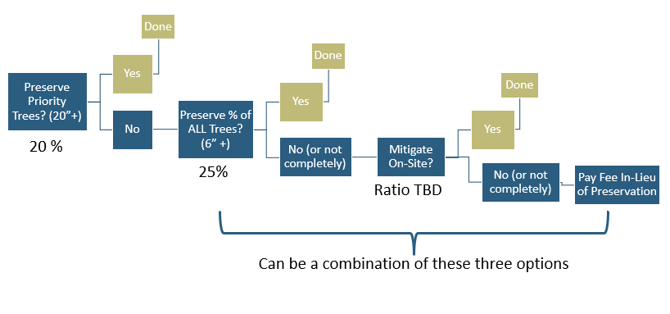
What the committee said:
- In general, the committee was in favor of having a code that requires developers to replant trees based on tree size. For example, a tree with a 30 inch diameter at breast height (which is measured at the 4 ½ foot mark of a tree) that is taken out by a developer would need to be replaced with multiple smaller trees versus a 6 inch tree, which would only require one tree be planted to replace it.
- The committee is preliminarily in favor of the following ratios. These ratios mean for every tree of a certain size that gets taken out, a certain number of new trees would be planted to replace it
6” to 9.9” – One tree
10” to 19.9” - Two trees
20” or larger - Four trees
- Larger trees would be prioritized for preservation because under this model, taking out a tree larger 20 inches or larger would mean a developer would have to pay for the planting of multiple new trees.
- The committee considered the question of whether trees that are required to be removed in the public right of way for things like utilities and other infrastructure should be counted for mitigation. A majority vote decided the trees should be counted in the total count of trees on a property.
- An arborist on the committee emphasized the importance that just planting trees is not enough, but that planting the right kind in the right place so they survive is key to meeting the City Council’s tree goals.
For the entire conversation, watch a recording of the meeting on Youtube.
cOMING UP: continuing the discussion
The next meeting has not been set yet. The topic will be around how trees will be regulated depending on lot size.

