Tree Regulation Update Advisory Committee Meeting Recap

Oct. 4, 2023
Want to stay in the loop about tree regulation? Here’s what you need to know.
The context:
Earlier this year, the Bend City Council created a temporary committee – The Tree Regulation Update Advisory Committee (TRUAC) – to explore preserving trees during new development while producing needed housing in the community.
The Council has explicitly directed this committee to focus on rules related to new, large-scale developments – like large subdivisions or commercial projects – rather than regulating what an individual homeowner, for example, chooses to do with a tree on their property.
Not finalized Re commendations to Date:
- Inventoried and Mapped Trees (Regulated Trees): 6” or larger (Deciduous and Coniferous)
- Priority Trees for Preservation: 20” or larger (Deciduous and Coniferous)
- Preservation percentages: 20% of priority trees would need to be preserved, or 25% of the total diameter at breast height (DBH) on a site would need to be preserved
The discussion focused on:
- The discussion focused largely on percentages: one percentage that would dictate a certain number of priority trees would be preserved, and another percentage that measures a certain amount of DBH – which stands for diameter at breast height. This is the way the circumference of trees are measured to determine size.
- The committee reviewed a flowchart (see below) of options that first incentivizes developers to save priority trees on a site. If they cannot save a percentage of priority trees or there are none on the site, then a developer can preserve a certain percentage of DBH on the site. For example, if there are 10 trees on site that has a DBH of 10 inches, the total DBH on the site is 100 inches. If the standard was to preserve 30% of the total DBH on a site, that would mean 30 inches worth of trees on the site would need to be preserved, so in this case that would mean three, 10-inch trees.
- If the developer couldn’t do either of these options, the next option would be replanting a certain of trees or paying a fee in lieu of preservation.
- The committee also discussed whether trees that are in the public right of way should be counted in these equations. The public right of way is land that is owned by the public for transportation and utility facilities.
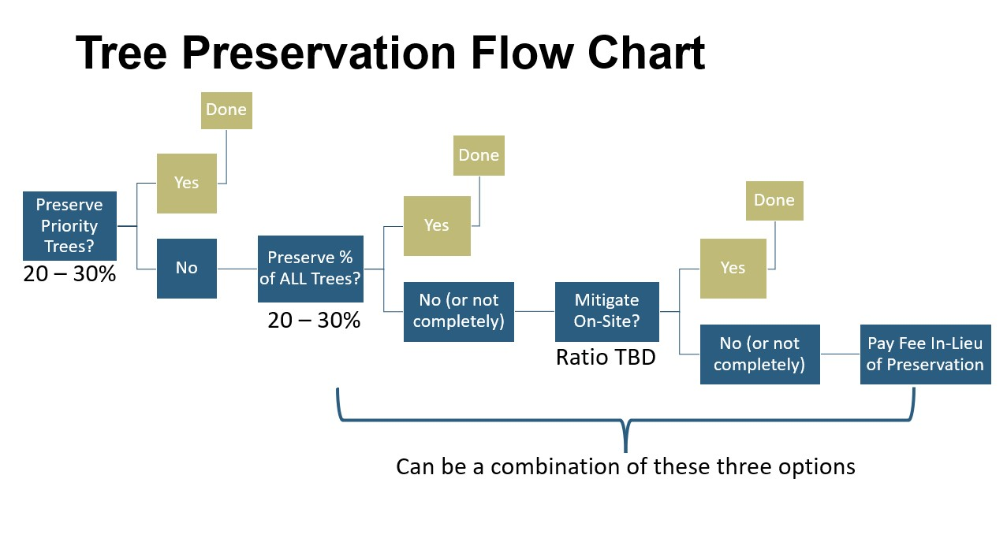
What the committee said:
- In general, the committee was more in favor of a lower preservation percentage for priority trees than for total DBH on the site. At the moment, that would be 20% of priority trees would need to be preserved, or 25% of the total DBH on a site would need to be preserved. Some members of the committee believe a lower percentage for priority trees will incentivize developers to keep them, because the lower the percentage, the easier it is to meet.
- Some on the committee suggested trees that have to be cut down in the right of way to meet City infrastructure requirements should not be counted in these percentages. This is because a developer doesn’t have a lot of discretion on whether they get cut down or not. In order to not include trees in the Right of Way when calculating these percentages, staff would have to provide additional information since current data to date includes the Right of Way.
- If public right of way is included, some advocated that the preservation percentages should be higher to capture and preserve more of the trees on site.
- The committee also discussed flexibility for small lots under one or two acres, which would struggle to meet requirements due to lack of space.
For the entire conversation, watch a recording of the meeting on Youtube.
cOMING UP: continuing the discussion
The conversation will continue at the Bend City Council meeting on Oct. 18, from noon to 2 p.m.

